32.47: The power from the antenna is 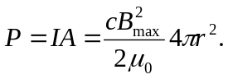 So
